**Pixel Art Creator**

Deadline 26th November 2024

10% to 15%

Draft

Your name and student number must be at the top of every file.

No form of plagiarism is allowed including Generative AI.

To Upload:

Upload all source files and data files you create.

You must upload the code to blackboard before even if not all the questions are completed.

**You must upload the code and demo** to get a mark.

Your mark will depend on your answers to code questions as well as submitted code.

Example

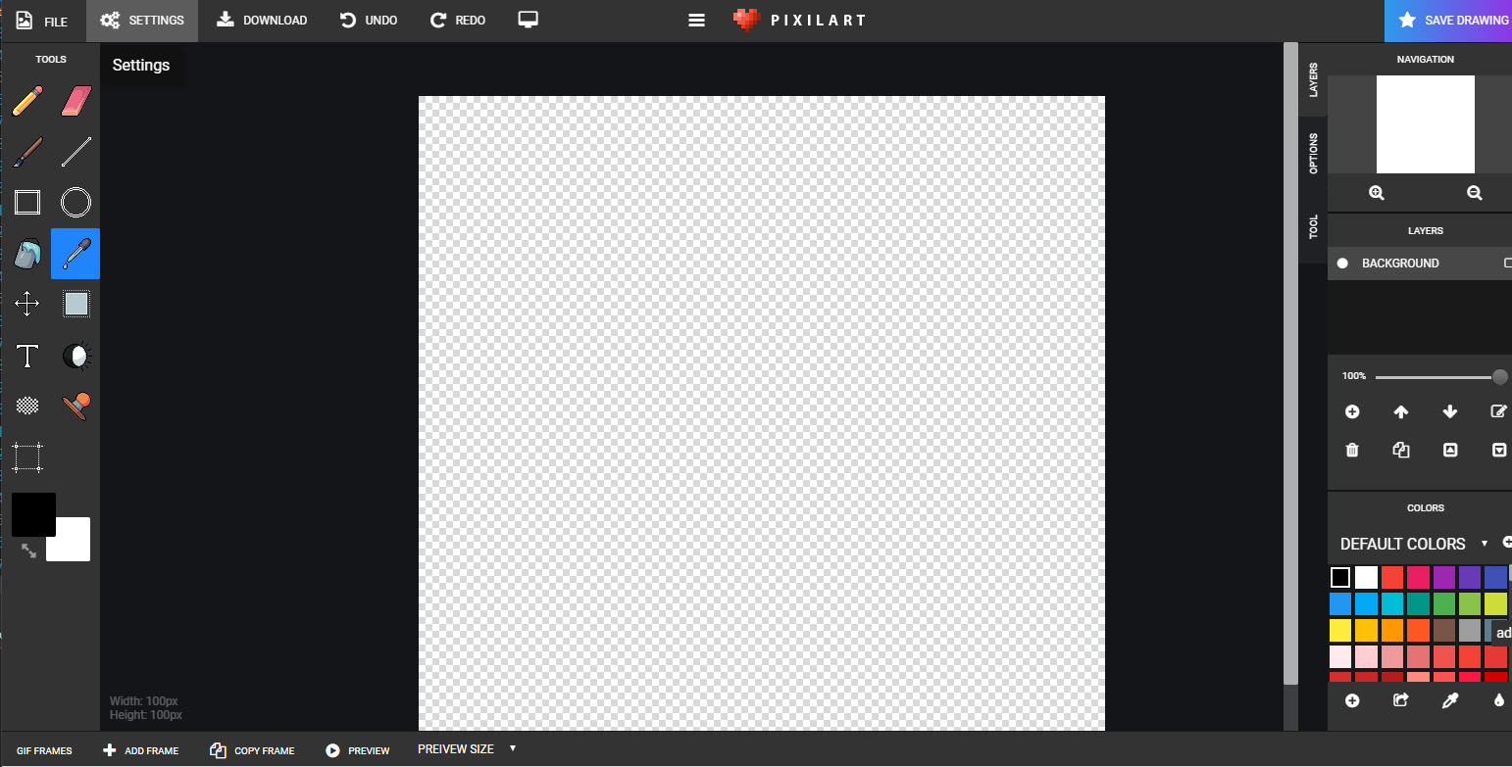

<https://www.pixilart.com/draw>

All must be your own work.

* Use the Raylib starter project

Add raygui.h from blackboard to main.c ( rename main.c to main.cpp)

Place raygui.h in the same folder as main.cpp

Copy the code from art.cpp on blackboard to main.cpp

* Add buttons as in left of pixel art
* Add colour selection grid
* Add a drawing grid
* Add painting one block
* Add changing the colour with colour picker
* Adding eraser
* Add saving and loading
* Add drawing a rectangle
* Add selection tool with copy and paste.
* ……..